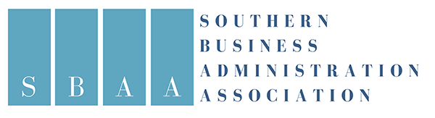

2021 SBAA Societal Impact Award:
Wright School of Business Collaborative Online International Program
Submitted by:
Maria Carolina Hammontree
Lecturer in Management
Dalton State College
Wright School of Business
Dalton, GA 30720
Cell: 423-8027910
mhammontree@daltonstate.edu

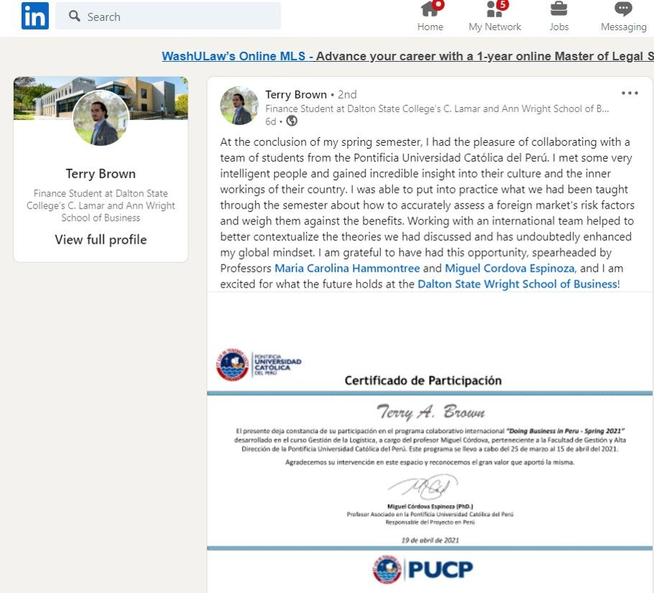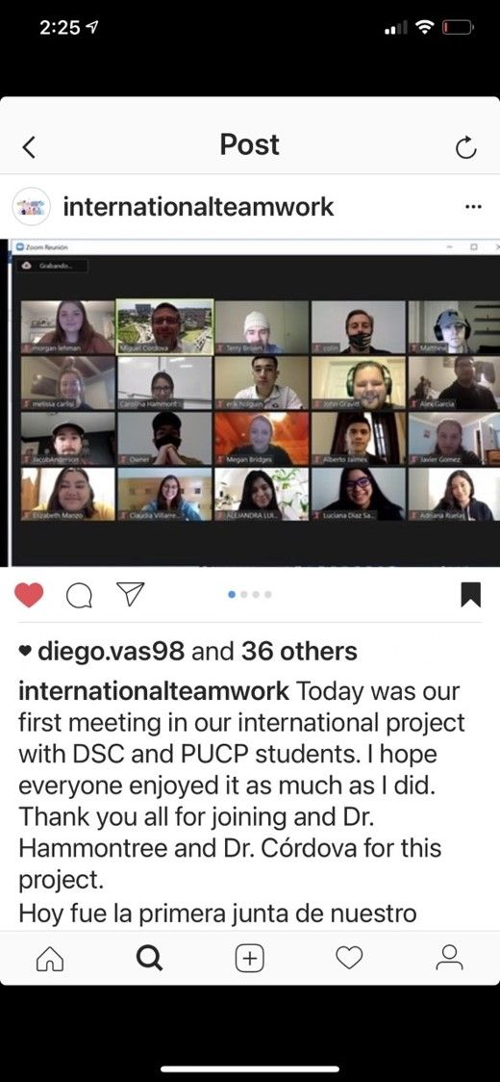

Wright School of Business Collaborative Online International Program.
I. a) Describe the strategy or program. The Wright School of Business (WSOB) at Dalton State College (DSC) in Dalton, GA is committed to using innovative instructional practices to improve students' engagement and awareness of the global environment and international business issues. Technology had allowed us to increase our creativity and build ongoing international relationships with other AACSB-accredited business schools while collaborating remotely. Because cultural intelligence is a vital skill for business professionals working internationally or as part of diverse teams, the WSOB constantly researches new ways to enhance our students' global mindset and worldview through critical thinking skills. "Partnerships with AACSB business schools in Latin America" is but one example. The international partnership has opened myriad innovative online international collaborations among business faculty members and students from the United States and other countries including Peru, Venezuela, Panama, the Dominican Republican, Mexico, Argentina, and Chile. Our Spring 2021 Undergraduate Collaborative Online International Four-Week Program entitled "Doing Business in Peru" was a partnership with faculty members and students from the Pontificia Universidad Católica del Peru (PUCP CENTRUM) in Lima, Peru and the WSOB at DSC and was implemented at no cost for students on either campus.
To plan and organize the program, the faculty organizers identified global supply chain management and international business—key business areas related to our joint teaching focus—and selected entrepreneurship as a focus. Next, we established the learning outcomes of the program. The central questions of the collaboration were: (1) What challenges do you find in doing business in Peru? and (2) How may these challenges prompt or constrain local and regional supply chains that serve foreign investment in Peru? Finally, we offered our spring 2021 classes on the same days and times in both Lima, Peru, and Dalton, GA. In this case there was only a one-hour time zone difference to account for, which made planning and scheduling easier.
The program's primary goal is to offer students an international and multicultural environment to improve and expand their global mindset. To make this possible as well as enhance the learning experience of our students, we created a simulated business working environment with the following assumptions: The DSC business professor and students work for an international corporation called DSCGlobal. This company is planning its global expansion in several world areas. The DSC business students are members of the team responsible for evaluating DSCGlobal's expansion in South America. After analyzing several South American countries using the EPIC (Economy, Politics, Infrastructure, and Competency) framework (Srinivasan, Stank, Dornier, & Petersen, 2014), the team identified Peru as one of its top options. The counterparts, the Peruvian professor and students work for a consulting company in Peru called PUCPInternational; the Peruvian team's mission is to support the American investors in developing an in-depth analysis of Peru and identifying business opportunities and challenges when doing business in Peru. The DSC and PUCP professors represented the Chief Executive Officer (CEO) of DSCGlobal and PUCPInternational, respectively.
The professors prepared the students for the project during the first two weeks of the collaborative online international four-week program. Both professors were international guest speakers in each other's classes and shared their international business and supply chain management perspectives. Also, other professors invited to participate in this online program included our embedded DSC librarian, Ms. Amy Burger, who supported the Peruvian and American students to locate references from databases for their research. After the first two classes of the program, the professors divided students into teams of eight business students each. Each team had American and Peruvian students representing each organization (DSCGlobal and PUCPInternatinal). The professors designed an ice breaker activity where the students introduced themselves and shared how the COVID-19 pandemic has impacted their lives. Then they found similarities and differences related to this topic among them. This activity helped them create positive relationships (Schein, 2013) among them and facilitated their learning experience in the program (Merriam & Bierema, 2014). The professors delivered a project agenda to each student with Zoom links/team, detailed directions, team goals to achieve in each virtual meeting, and days and times required to meet virtually and finally present their results. At the end of the program, the students received a certificate from PUCP CENTRUM.
I.b) The uniqueness of this program includes: Global partnerships with AACSB business schools in Latin America, technology for virtual class meetings, low-cost implementation, and out-of-class work by students to make the collaborative online international program an even more impactful international learning approach. This international strategy facilitates faculty members in offering a unique international experience to students in their own country. Also, the program is flexible and allows faculty: a) to strengthen their global network, b) customize international business projects based on the learning outcomes of their courses and resources, c) begin joint research projects with foreign professors, d) innovate their teaching approach (high-impact practices), e) implement a virtual international teaching approach for the COVID-19 pandemic, and beyond. Most importantly, the students who participated in the collaborative online international programs enriched their multicultural intelligence, international networks, and friendships (e.g., via WhatsApp, email, and Instagram). These contacts may also foster further new business creation and entrepreneurship among the student groups as well as increase joint travel between the new classmates.
II. a) Description of how this approach or program is a force for good and the positive impact it has in the local community and more broadly on society. We live and work in a global business world. There is an extremely high probability that our business students will be doing business with suppliers and customers from other countries. Therefore, international partnerships with foreign universities will ensure our students enhance their international business and multicultural skills, allowing them to make better and sustainable business decisions while always considering global issues. The WSOB at DSC is educating future business leaders of our community. Our students will enhance their international leadership skills and understand the main challenges of overseas business, specifically in Latin America. Thus, we are strengthening the decision-making process of our business students to help them make a better contribution to our worldwide society. Additionally, DSC is a Hispanic Serving Institution (HSI), and more than 33% of our student population are Hispanics; so, learning and collaboration with Latin American universities aligns perfectly with our unique HSI mission. Partnerships with Latin American Universities bring more of the diverse Hispanic culture to our institution, extending the reach of our internationalization mission.
II. b) Documentation of the size of the impact and/or outcomes of strategy or program. The spring 2021 collaborative online international four-week program was an excellent international learning experience that impacted almost 80 participants (faculty and students). During the first session where the Peruvian and American students met, some instantly created an Instagram account, and others started using "WhatsApp" to communicate and then keep their friendship after the program, increasing their international professional and social network. Additionally, some students posted their learning experiences during the program and how they impacted their professional lives on LinkedIn.com. Once the program ended, the professors created and administrated a survey to both the Peruvian and American students to gauge the impact of this internationalized experience. After organizing the data, individually and collectively reviewing the transcribed database, coding, and organizing themes, we better understand that the collaborative online international four-week program impacted our students' perspective on doing business overseas. Emerging themes included: a) Empathy in understanding other perspectives (e.g., "It helped a good bit. I have never worked with students outside of the US before, and this changed my perspective" "grow culturally" "It helped me realize that not every country around the world has the same tools and opportunities that we do in the US"), b) Knowledge of global issues (e.g., "It helped me gain a better understanding of life in a foreign country. With the election going on in Peru, we had a great opportunity to learn about how officials can affect businesses in a foreign country." "Having someone that is in the country and experiences everything that is going on the first hand is very insightful, I made friends, and I learned more of the political, economic, and social aspect of Peru." c) Connection with international peers (e.g., "The Peruvian students were very helpful, and we even talked way past the class time." "Being able to speak to foreign students my age was very helpful."), d) Belief in this activity's application for workplace skills (e.g., "It was preparatory for the work I will do after graduation"). Moreover, many students showed interest in learning Spanish as a second language. During summer 2021, both institutions organized a program entitled "Meet&Talk," where Peruvian and American students and alumni can meet and talk to practice a second language (DSC is offering this program in fall 2021).
III) Applicability to other institutions. The Collaborative Online International Program is applicable and widely affordable in any AACSB business school (graduate or undergraduate). The center of this international strategy is to build a global network with faculty members from foreign universities from countries relevant to your institution's strategic goals. How can one set up these partnerships? Attending conferences is one way; for example, the Academy of International Business (AIB) is an excellent venue to connect with other professors and increase your international network. Then one needs to be intentional and express the desire to collaborate. It is a win-win relationship for the AACSB business schools participating. The online collaboration could be between professors with the same or different areas of expertise (e.g., marketing and supply chain management). Next, start working on the agreement (memorandum of understanding) between the universities needed to make this possible. It is necessary to acknowledge that to make this program possible, the support by the dean was vital. Some other ideas of online international collaborations are: international guest speakers, international faculty and students exchange, international faculty and students research symposiums, international webinars, international internships, online study abroad, faculty research, and learning a second language. Our program, Partnerships with AACSB business schools in Latin American has created further opportunities for online international collaborations, improving our students' global mindset, the internationalization of the WSOB at DSC, faculty members' international research and network, and students' international network.

