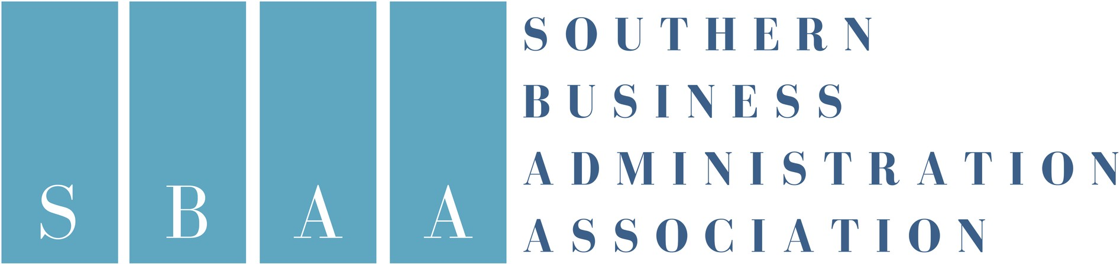
For questions or additional information, contact:
Marilyn Macik-Frey, VP Program, SBAA
marilyn.macik-frey@nicholls.edu

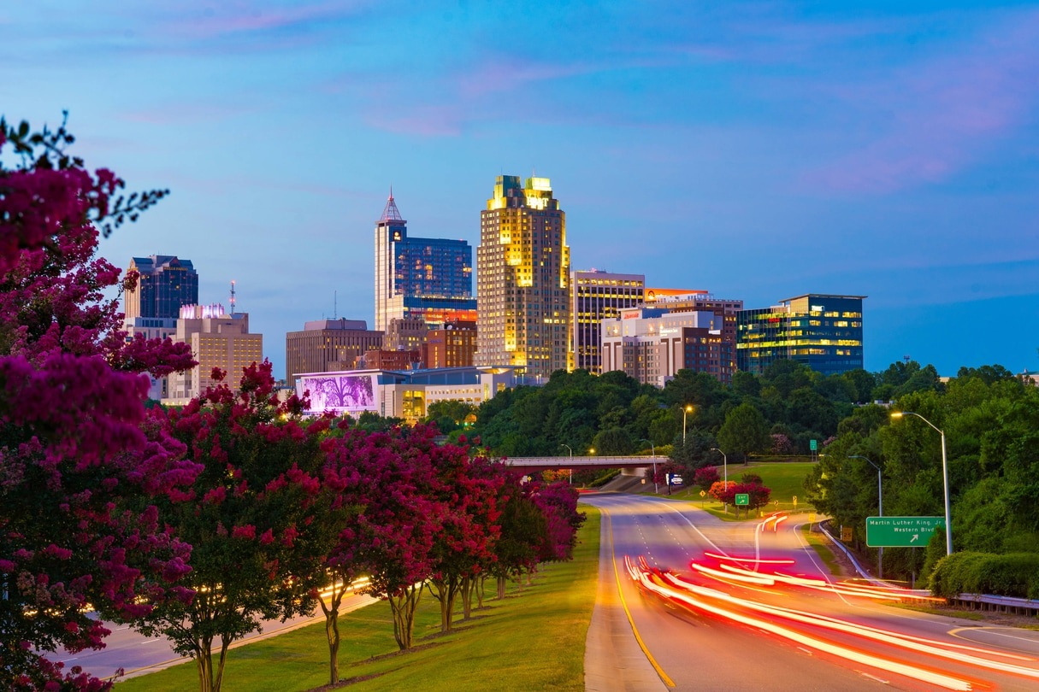

SBAA Annual Meeting

November 13-15, 2022

Join other business school deans for the Southern Business Administration Association Annual Meeting at the Raleigh Marriott City Center in Raleigh, NC. The workshop provides great networking opportunities with other schools.

The Workshop begins with registration on Sunday at 3:00 PM, followed by a reception and dinner at 6:00 PM. The workshop will conclude by noon on Tuesday.

The agenda will be posted on the SBAA website soon.

www.southernbusinessdeans.org

For questions related to registration or hotel reservations,
please contact Brynn Dillon at bdillon@columbusstate.edu.

ANNUAL MEETING
$300 REGISTRATION FEE
Complete the registration form with payment by October 12, 2022, or register online.

HOTEL RESERVATIONS:
A block of rooms has been reserved for a group rate of $189 per night.
Deadline is October 12, 2022. Reservation line is 888-236-2427. Use Group Code: SBAA
Reservation link available on our website.

SBAA MEMBERSHIP
$200 ANNUAL FEE
To join, complete the SBAA Membership form for 2022 and remit with payment, or pay online.
One institutional membership required per year.

